Sales Data Analysis Report

Intern Name: Rahul Sharma

Company: Brainwave Matrix Solutions

Date: 10 May , 2025

# Introduction

# This report presents an analytical overview of sales data from a retail superstore. The objective is to identify key trends in sales, profits, shipping methods, and customer behavior using tools such as Python and Power BI.

# 2. Monthly Sales Overview

Monthly sales were analyzed over the years 2019 and 2020. A clear upward trend was observed, especially in Q4 of 2020, with December showing the highest sales spike at **$166,185.85**.

**Visualization:** Line chart showing YoY monthly sales comparison (2019 vs 2020).

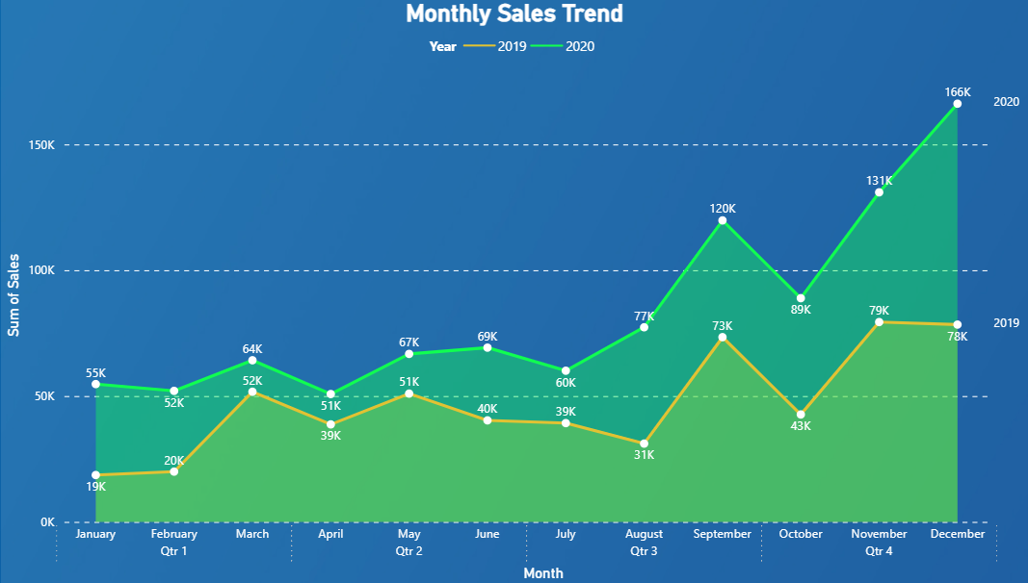

**3. Top Performing Categories & Sub-Categories  
  
By Category (Total Sales):**  
  
· **Office Supplies**: $643,707.69

· **Technology**: $4,70,587.99

· **Furniture**: $4,51,508.65  
  
  
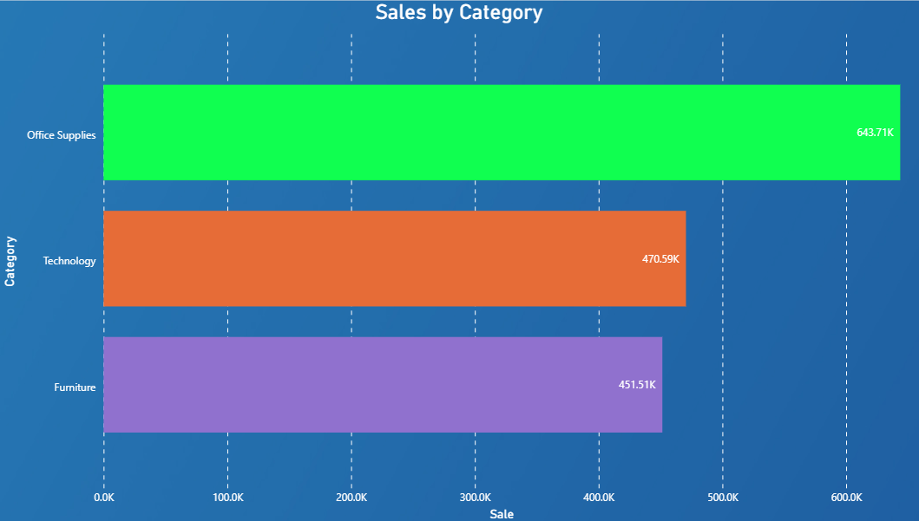

**By Sub-Categories :**  
  
· **Phones**: $196,563.55

· **hairs**: $181,946.00

· **Binders**: $174,978.39

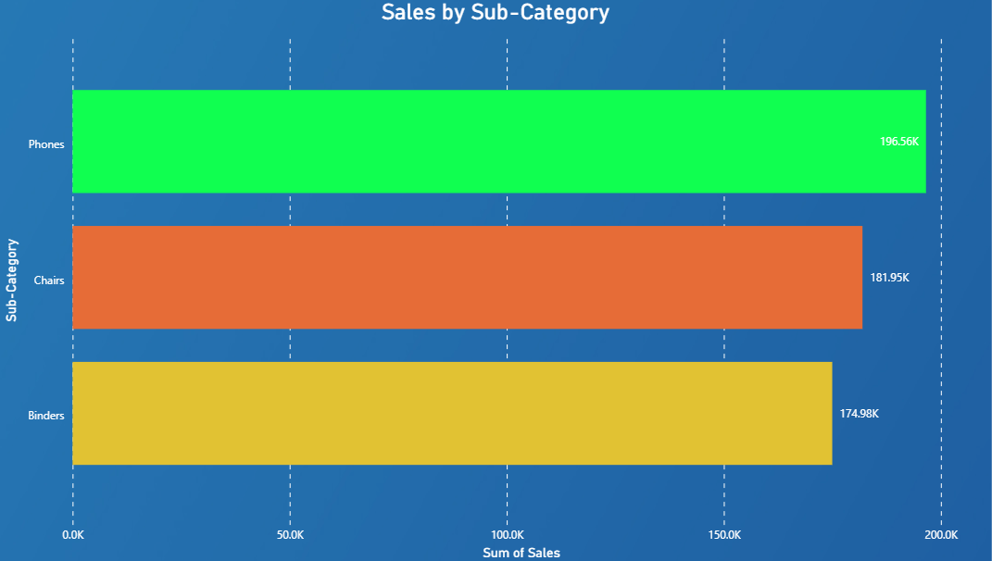

**Visualization:** Clustered bar charts for categories and sub-categories by sales.

# 

**4. Shipping Mode Analysis**

Among all shipment options, Standard Class was most preferred with over $912K in sales. This suggests it is the go-to mode for cost-effective delivery.  
  
**Ship Mode Breakdown:**

* Standard Class: $303K
* Second Class: $112K
* First Class: $82K
* Same Day: $30K

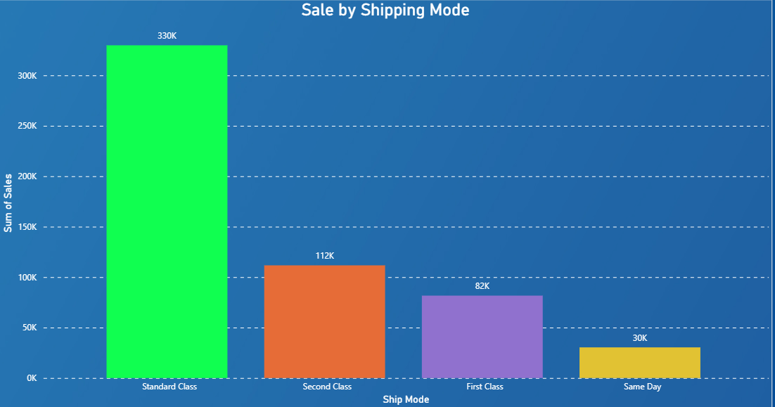

**Visualization:** stacked bar showing sales by shipmode.  
  
  
  
  
  
  
  
  
  
  
  
**5. Regional Sales Performance**

The West region led in sales contribution with $522,441.05, followed by the East and Central regions.

**Sales by Region**:

* West: $171K
* East: $169K
* Central: $133K
* South: $81K

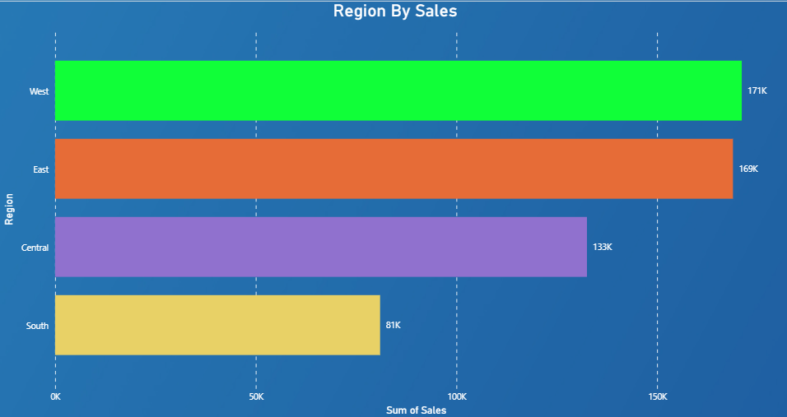

**Visualization:** Regional map or stacked column chart.

**6. Power BI Dashboard & KPIs**

An interactive Power BI dashboard was created to present key performance indicators (KPIs) and data visualizations that enable quick insights and deeper exploration. The dashboard includes filters by region, category, sub-category, and ship mode.

### **Key KPIs Displayed:**

**- Total Sales:** $1,565,804.32

**- Total Orders:** 7,298

**- Total Profit:** $175,262.11

**- Average Ship Time (Days):** 4

**- Top Region by Sales:** West ($522,441.05)

**- Top Category by Sales:** Office Supplies ($643,707.69)

**- Top Sub-Category:** Phones ($196,563.55)

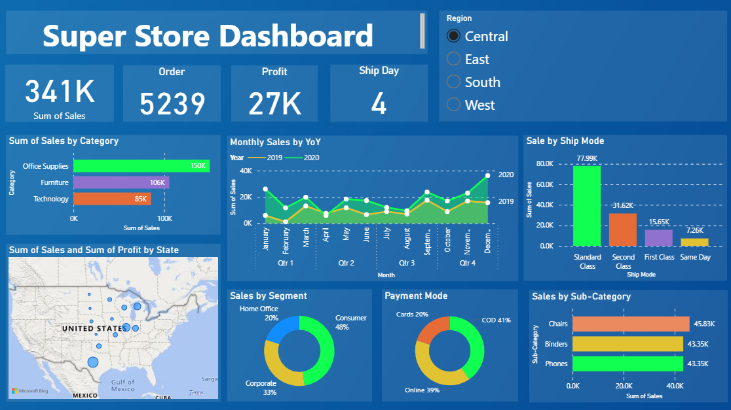

# Dashboard Visualizations:

**Sales by Category:** Horizontal bar chart showing sales across Furniture, Office Supplies, and Technology.

**Sales by Sub-Category:** Bar chart highlighting top-performing items like Phones, Chairs, and Binders.

**Monthly Sales Trend (YoY):** Line chart comparing monthly sales for 2019 and 2020 to identify seasonal patterns.

**Sales by Ship Mode:** Bar chart showing distribution across Standard Class, Second Class, First Class, and Same Day.

**Sales by Region:** Map visualization and summary table to show regional performance.

**Sales by Segment:** Donut chart showing Customer Segments (Consumer, Corporate, Home Office).

**Payment Mode Breakdown:** Donut chart representing share of payment methods (Cards, Online, COD).

### **Interactivity Features:**

**Slicers** for:

Year selection (2019, 2020)

Region filter (Central, East, South, West)

Category/Sub-Category

Ship Mode & Payment Mode  
  
7. Insights & Recommendations

Prioritize inventory for **Office Supplies** and **Phones**, which lead in sales.

Optimize **Standard Class** logistics, as it’s the most used shipping mode.

Monitor **Furniture** category profitability, as it has the lowest profit margin despite high sales.

### 8 . Tools Used

**Power BI**: Interactive dashboard creation

**Excel**: Data pre-processing and pivot summaries